CD Assignment 6

----------------------------------

Name: Yash Oswal

Div: B Roll no.: 38

SRN: 201901226

----------------------------------

Question:

Implement the following code optimizations on the input 3-address code in the form of quadruples:

a) Common subexpression elimination

b) Constant folding

Input:

1. Code Optimization:

+ y z t1

= t1 x

+ b c t2

= t2 a

+ y z t3

= t3 j

= x b

+ b c t4

= t4 d

* b c t5

= t5 f

+ y z t6

= t6 g

1. Constant folding:

= 30 c

+ y z t1

= t1 x

+ b c t2

= t2 a

+ y z t3

= t3 j

= x b

= 20 b

+ b c t4

= t4 d

* b c t5

= t5 f

+ y z t6

= t6 g

=================================================================

Output:

1. Code Optimization

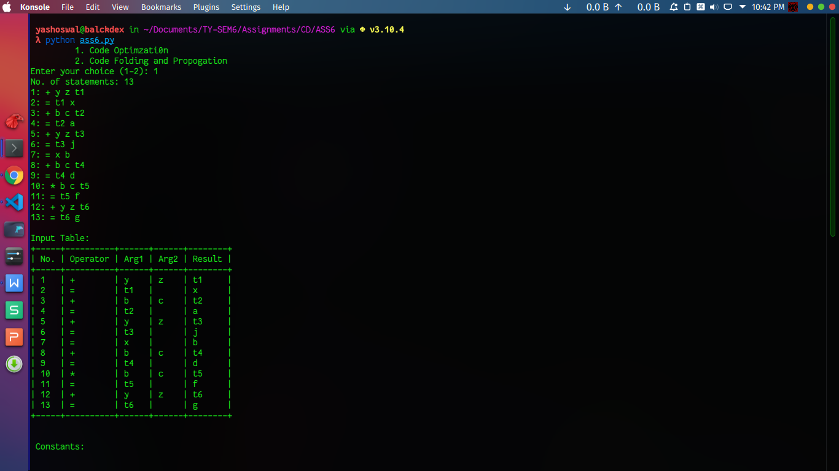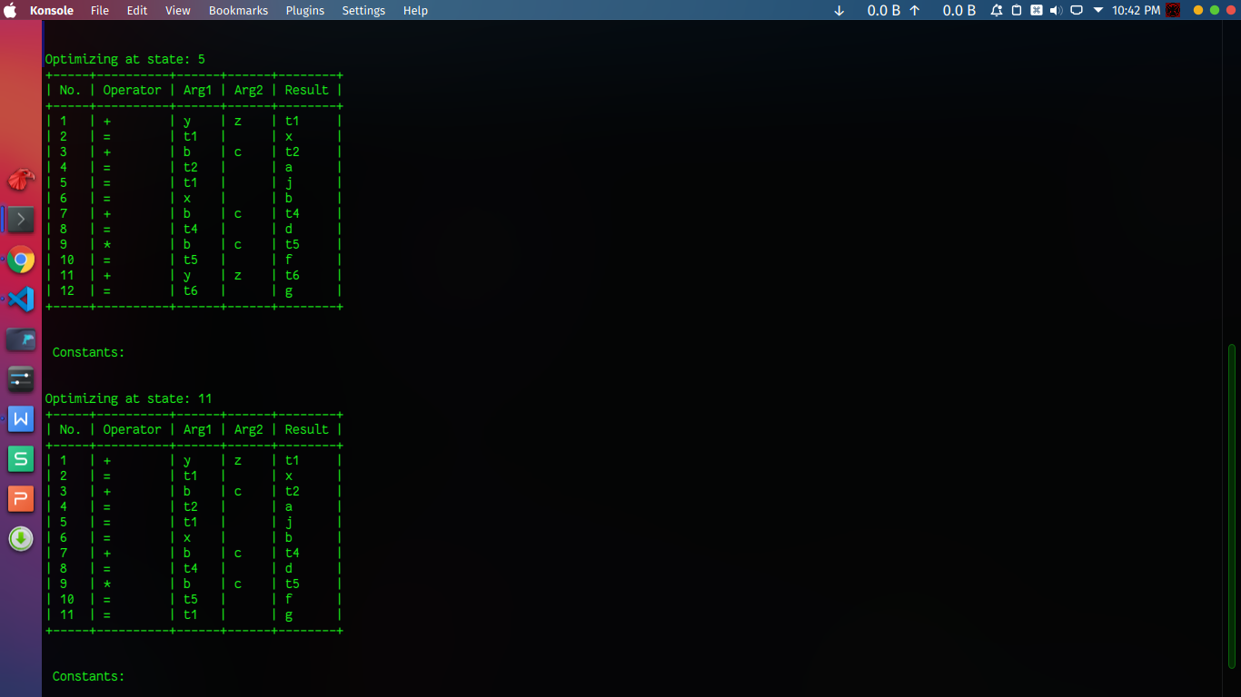

1. Constant Folding

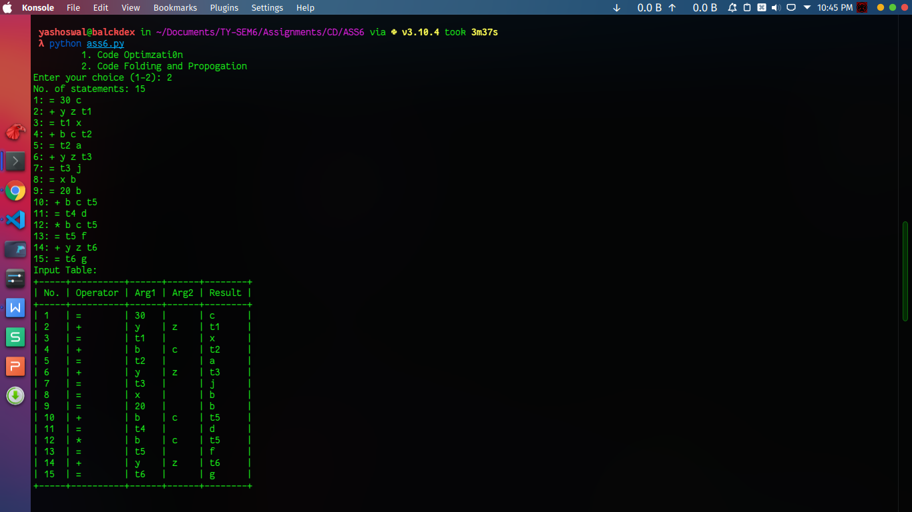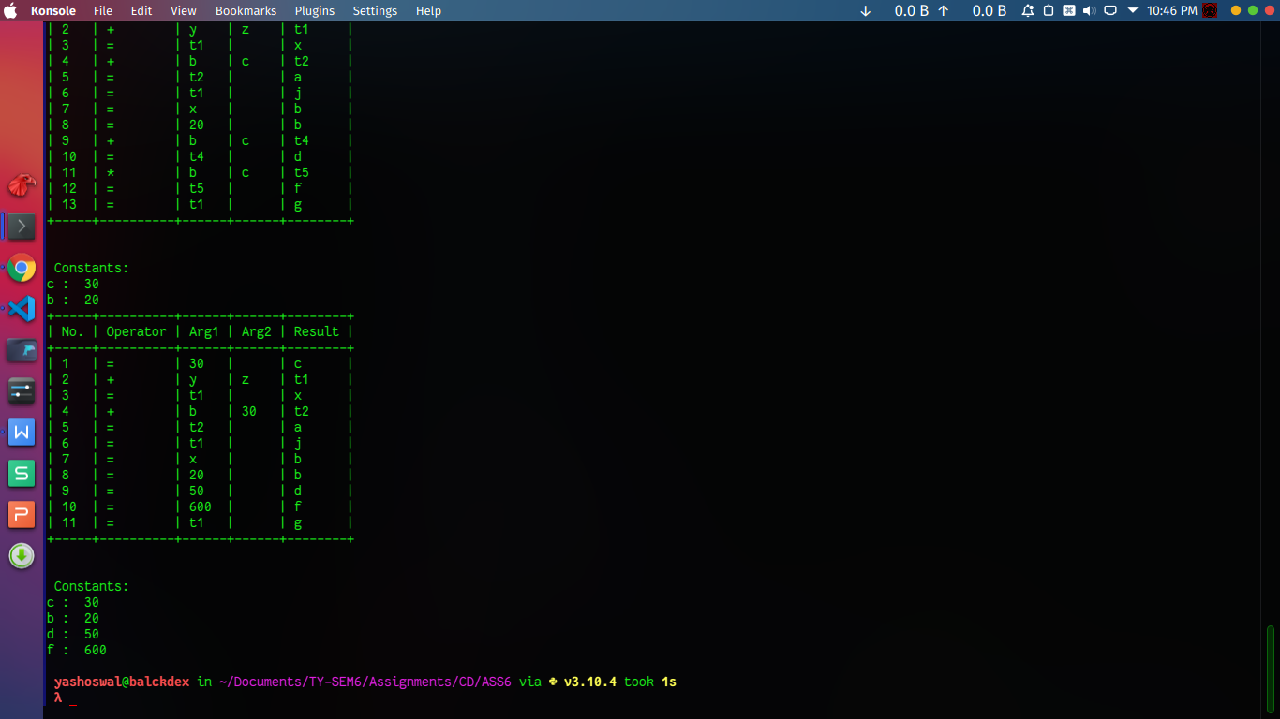

Code:

class CodeOptimization():

quadrapleTable = []

noOfStatements = 0

result = []

constants = {}

def takeInput(self) -> None:

state = []

self.noOfStatements = int(input('No. of statements: '))

for i in range(self.noOfStatements):

a = input(f"{i+1}: ")

state.append(a)

self.makeQudraple(state)

def makeQudraple(self,inputStates:list) -> None:

self.noOfStatements = len(inputStates)

for n in range(self.noOfStatements):

var = inputStates[n].split(' ')

if len(var) == 4:

self.quadrapleTable.append([n+1, var[0], var[1], var[2], var[3]])

elif len(var)== 3:

self.quadrapleTable.append([n+1, var[0], var[1], " ", var[2]])

if var[1].isnumeric():

self.constants.update({var[2]:[var[1],n]})

def optimize(self) -> None:

self.result.append(self.quadrapleTable[0][4])

n=1

self.result.clear()

self.result.append(self.quadrapleTable[0][4])

while(1):

if n >= self.noOfStatements:

return

for i in range(n-1,-1,-1):

if (self.quadrapleTable[n][1] == self.quadrapleTable[i][1] and #

(self.quadrapleTable[n][2] == self.quadrapleTable[i][2] or self.quadrapleTable[n][2] == self.quadrapleTable[i][3]) and

(self.quadrapleTable[n][3] == self.quadrapleTable[i][3] or self.quadrapleTable[n][2] == self.quadrapleTable[i][2])):

if self.quadrapleTable[n][2] not in self.result and self.quadrapleTable[n][3] != self.quadrapleTable[i][4]:

print(f'\n\nOptimizing at state: {n+1}')

self.quadrapleTable.pop(n)

self.noOfStatements-=1

self.quadrapleTable[n][2] = self.quadrapleTable[i][4]

s.printQuadTable()

self.result.append(self.quadrapleTable[n][4])

n+=1

def constantFoldingAndPropogation(self):

self.result.clear()

self.result.append(self.quadrapleTable[0][4])

n=1

while(1):

if n >= self.noOfStatements:

return

for i in range(n-1,-1,-1):

if self.quadrapleTable[i][2] in self.constants.keys() and i >= self.constants.get(self.quadrapleTable[i][2])[1]:

self.quadrapleTable[i][2] = str(self.constants.get(self.quadrapleTable[i][2])[0])

if self.quadrapleTable[i][3] in self.constants.keys() and i >= self.constants.get(self.quadrapleTable[i][3])[1]:

self.quadrapleTable[i][3] = str(self.constants.get(self.quadrapleTable[i][3])[0])

if self.quadrapleTable[i][1] in ['+','-','/','*','%'] and self.quadrapleTable[i][2].isnumeric() and self.quadrapleTable[i][3].isnumeric():

if self.quadrapleTable[i][1] == '+':

sum = int(self.quadrapleTable[i][2]) + int(self.quadrapleTable[i][3])

self.quadrapleTable.remove(self.quadrapleTable[i])

self.quadrapleTable[i][2] = str(sum)

self.constants.update({self.quadrapleTable[i][4]:[(self.quadrapleTable[i][2]),i]})

self.noOfStatements-=1

if self.quadrapleTable[i][1] == '*':

sum = int(self.quadrapleTable[i][2]) * int(self.quadrapleTable[i][3])

self.quadrapleTable.remove(self.quadrapleTable[i])

self.quadrapleTable[i][2] = str(sum)

self.constants.update({self.quadrapleTable[i][4]:[(self.quadrapleTable[i][2]),i]})

self.noOfStatements-=1

if self.quadrapleTable[i][1] == '/':

sum = int(self.quadrapleTable[i][2]) / int(self.quadrapleTable[i][3])

self.quadrapleTable.remove(self.quadrapleTable[i])

self.quadrapleTable[i][2] = str(sum)

self.constants.update({self.quadrapleTable[i][4]:[(self.quadrapleTable[i][2]),i]})

self.noOfStatements-=1

if self.quadrapleTable[i][1] == '%':

sum = int(self.quadrapleTable[i][2]) % int(self.quadrapleTable[i][3])

self.quadrapleTable.remove(self.quadrapleTable[i])

self.quadrapleTable[i][2] = str(sum)

self.constants.update({self.quadrapleTable[i][4]:[(self.quadrapleTable[i][2]),i]})

self.noOfStatements-=1

if self.quadrapleTable[i][2].isnumeric() and self.quadrapleTable[i][1] == '=':

self.constants.update({self.quadrapleTable[i][4]:[int(self.quadrapleTable[i][2]),i]})

break

n+=1

def printQuadTable(self) -> None:

print('+-----+----------+------+------+--------+')

print('| No. | Operator | Arg1 | Arg2 | Result |')

print('+-----+----------+------+------+--------+')

for n in range(self.noOfStatements):

print("| {:<4}| {:<9}| {:<5}| {:<5}| {:<7}|".format(

n+1,

self.quadrapleTable[n][1],

self.quadrapleTable[n][2],

self.quadrapleTable[n][3],

self.quadrapleTable[n][4],

))

print('+-----+----------+------+------+--------+')

print("\n\n Constants:")

for i in self.constants.keys():

print(i,": ",self.constants.get(i)[0])

#__main__()

s = CodeOptimization()

print("\t 1. Code Optimzati0n")

print("\t 2. Code Folding and Propogation")

ch = int(input("Enter your choice (1-2): "))

if ch==1:

s.takeInput()

print("\nInput Table: ")

s.printQuadTable()

s.optimize()

elif ch == 2:

s.takeInput()

print("Input Table: ")

s.printQuadTable()

s.optimize()

s.constantFoldingAndPropogation()

s.printQuadTable()

else:

print("Enter Valid Choice")

exit(1)